Project Description

We made a event management system which make the user to create his / her event.

So it consists of:

**1 - Customer Module**

a. Enables customer to create account.

b. Enables customer to book an event with full details.

c. Enables customer to manage booking

**2 – Project Manager Module**

a. Enables PM to receive customer requests

b. Send customer requests to service provides and follow them

c. Enables PM to show bill for customer.

**3 – Service Provider Module**

a. Enables SP to receive customer requests from PM

b. Enables SP to price value of request and resend it to PM

c. Enables SP to determine ready date for request.

**4- Admin Module**

a. Enables admin to receive requests from customer and resend requests to PM

b. Enables admin to add users with different roles.

Database schema:

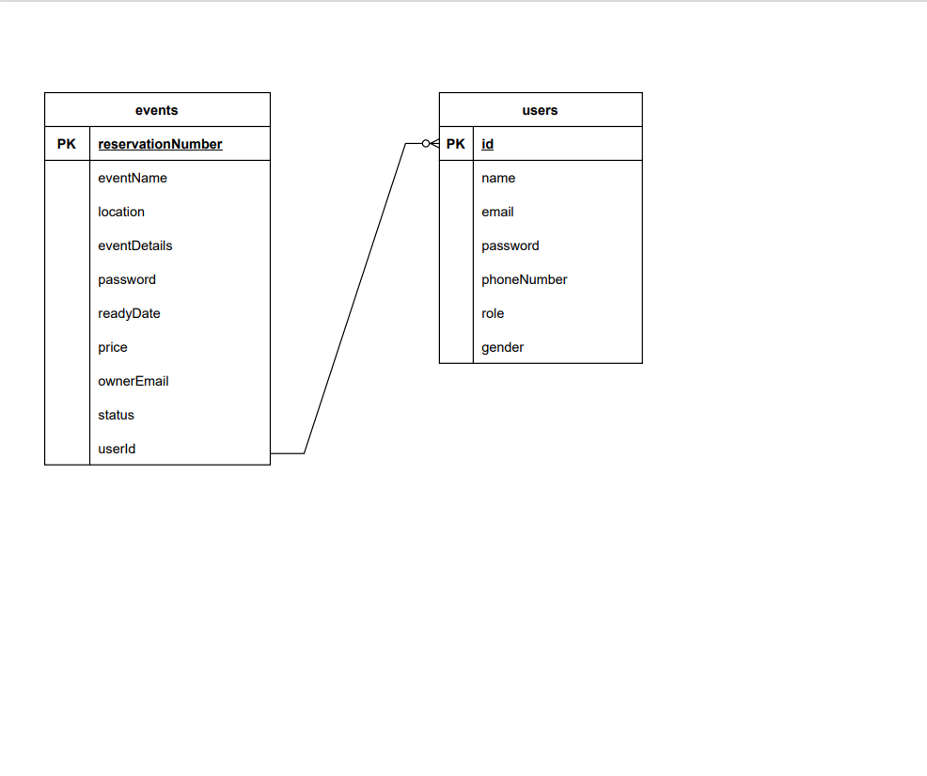

Class diagram: